**Columbus Computer Repair**

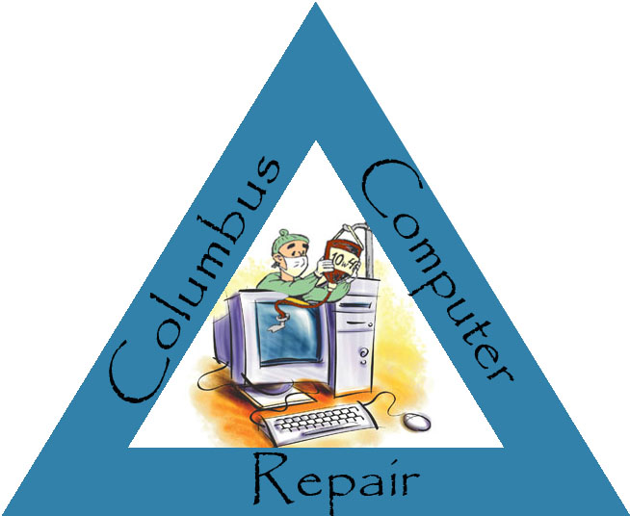

**Software & Database Training Materials**

**Program & Database Access**

For security reasons, it has been determined that certain user roles will be denied access to particular programs and access to the database for editing purposes.

**Programs**

|  |  |  |  |  |  |  |  |
| --- | --- | --- | --- | --- | --- | --- | --- |
|  | Customer | Employee | Part | Repair | Shop | Database | Accounting |
| Technician  **Users** |  |  |  | X |  |  |  |
| Inventory Associate |  |  | X |  |  |  |  |
| Retail Associate | X |  |  |  |  |  |  |
| Shop Manager | X | X | X | X | X |  |  |
| Corporate Manager | X |  | X | X | X | X | X |
| HR Representative |  | X |  |  |  |  |  |
| Analyst |  |  |  |  | X |  | X |
| Accountant |  |  |  |  |  |  | X |

**Table 1 –** Software, Database, and Accounting Package Access by User

**Software Access**

In addition to controlling access to Columbus Computer Repair’s software by using Active Directory, user access will be restricted by logging into the program.

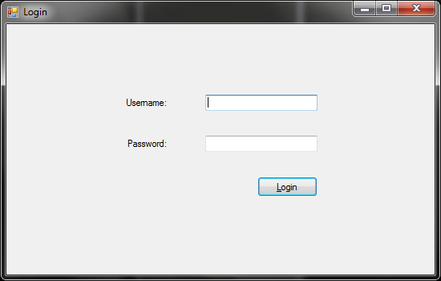

**Figure 1 – Standard Columbus Computer Repair Login Screen**

**Valid Username/Password Combinations**

|  |  |  |  |  |  |  |  |
| --- | --- | --- | --- | --- | --- | --- | --- |
|  | Technician | Inventory  Associate | Retail Associate | Manager | Corporate  Manager | HR  Representative | Analyst |
| Username | technician | inventory | retail | manager | manager | hrrep | analyst |
| Password | technician | inventory | retail | manager | manager | hrrep | analyst |

**Table 2 –** Usernames and Passwords

**\*\*Note:** Users needing access to Columbus Computer Repair’s Accounting Package will not need to log in for access to the corresponding Excel spreadsheets. Access to accounting spreadsheets will be available to those who need it through Active Directory.

**Database Access**

Database editing will be done primarily through the use of software designed in Visual Basic. In certain cases, however, updating and editing the database will be done by directly accessing Columbus Computer Repair’s main database, which was designed in Microsoft Access.

In those cases, access to the database will be controlled via a password. The password for access is: columbuscomputerrepair

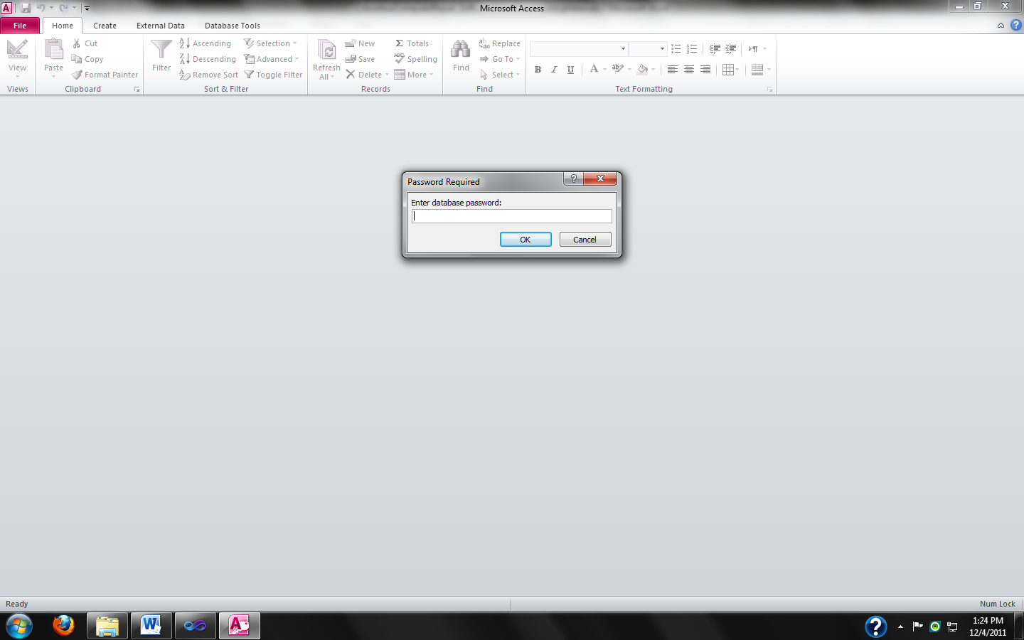

**Figure 2 – Columbus Computer Repair Database Access Restriction**

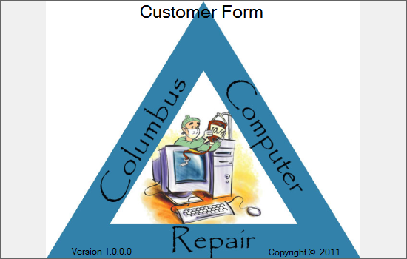

**Figure 3 – Columbus Computer Repair Customer Form Splash Screen**

**Introduction**

Columbus Computer Repair’s customer program allows users to add and delete customers from the database. The program will also allow users to update customer information as necessary. The following instructions will guide users through the steps necessary to maintain customer information in Columbus Computer Repair’s database.

**User Access**

User access is restricted to the following usernames: manager and retail.

**Viewing Customer Information**

1. Run CCR_CustomerForm.exe

Columbus Computer Repair’s splash screen should display, with the name of the form on the top (see Figure 3).

1. Log in to the form using proper credentials via the login screen.

You should see the following form (see Figure 4).

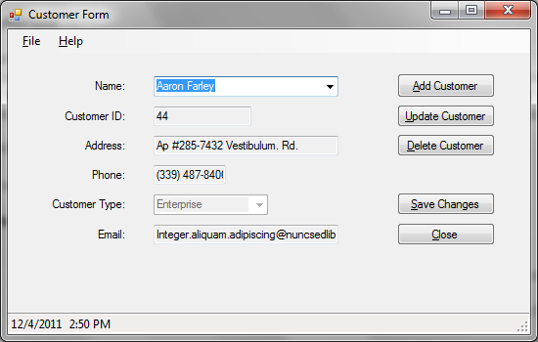

**Figure 4 – Customer Form Initial Screen**

1. To display a different customer’s information, click on the arrow next to the customer’s name. Navigate to the name of the customer you are searching for.

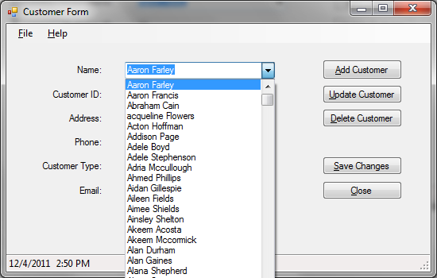

**Figure 5 – Customer Form Navigation**

To assist in navigation, begin typing the customer’s name into the box.

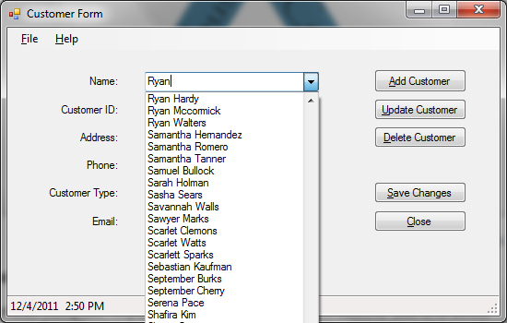

**Figure 6 – Customer Form Name Search**

**Updating Customer Information**

1. Navigate to the customer whose information you wish to update.
2. Click the **Update Customer** button.
3. Tab through the fields. Correct information by typing the new information in the box next the field you wish to update (see Figure 7). The status bar’s message will change to reflect that you are editing a customer record.

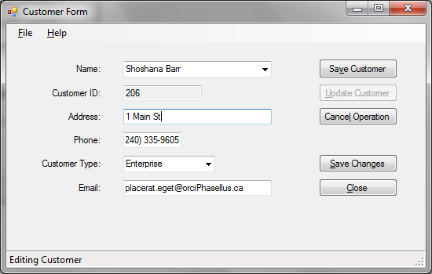

**Figure 7 – Customer Form Update Screen**

1. When you have entered the information correctly and have no further information to update, click the **Save Customer** button. The customer’s information has been updated.

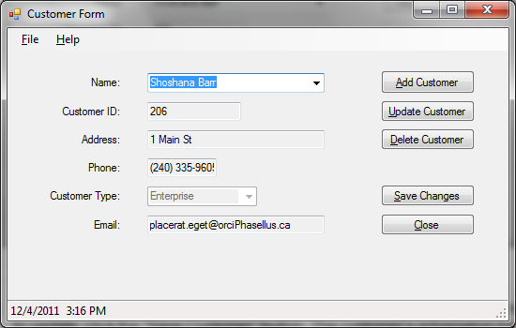

**Figure 8 – Customer Form Showing Updated Information**

1. If at any time you wish to stop editing a customer’s information, click on the **Cancel Operation** button. The Customer Form screen will return to normal.

**Adding a Customer**

1. Click the **Add Customer** button.
2. Enter the new customer’s information into the appropriate boxes. Click on the arrow in the box by customer type to select what type of customer you are adding. The status bar’s message will change to reflect that you are adding a customer record.

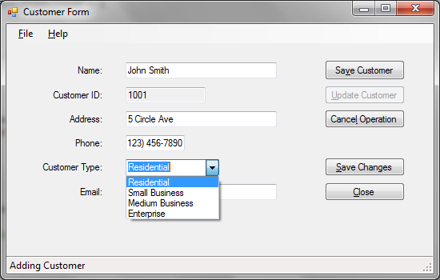

**Figure 9 – Customer Form Showing Customer Add**

1. When you have entered the information correctly and have no further information to update, click the **Save Customer** button. The customer’s information has been updated.
2. If at any time you wish to stop adding a customer, click on the Cancel Operation button. The Customer Form screen will return to normal.

**Deleting a Customer**

1. Navigate to the customer’s information you wish to delete.
2. Click the **Delete Customer** button. A dialog box appears to confirm deletion of the record.

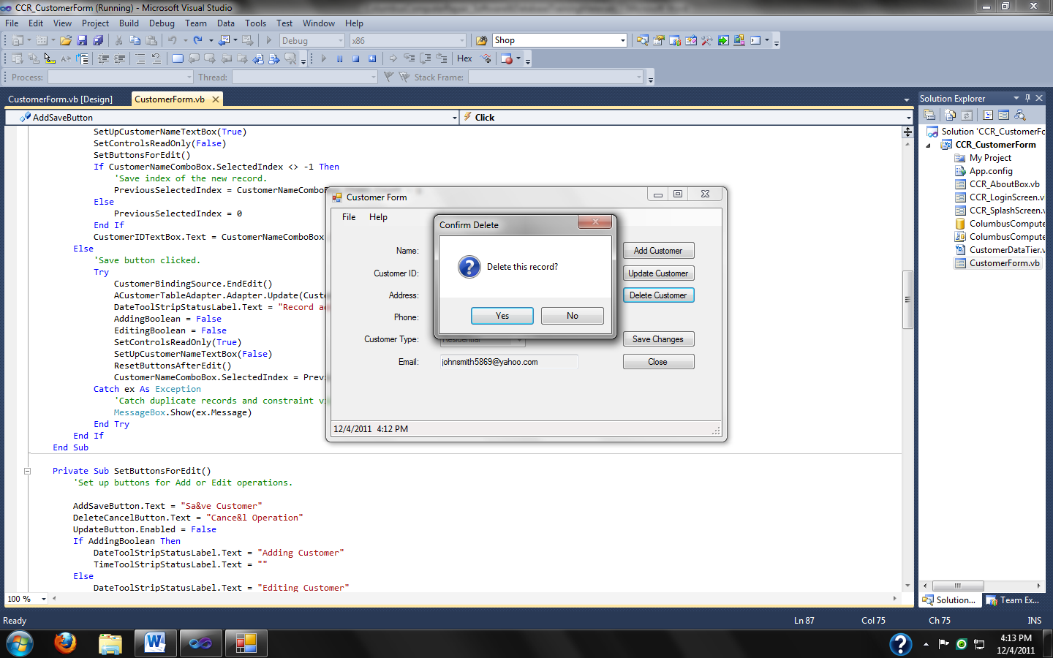

**Figure 10 – Customer Form Showing Delete Dialog**

1. Click “Yes” to delete the record. If you do not wish to delete the record, click “No”. The Customer Form should return to normal.

**\*\*Warning: Deleting customers should only be done with permission from your supervisor.**

**Saving Database Changes**

1. To save changes in the database, click the **Save Changes** button. Any changes you’ve made will be saved to the original database.

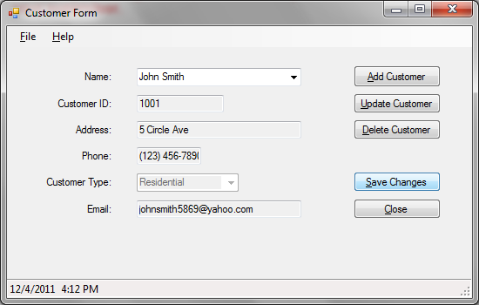

**Figure 11 – Customer Form Saving Database Changes**

**Displaying Program Information**

1. To display program information, click **Help** in the menu bar. Next click **About.**

The form’s about box should display information about the program.

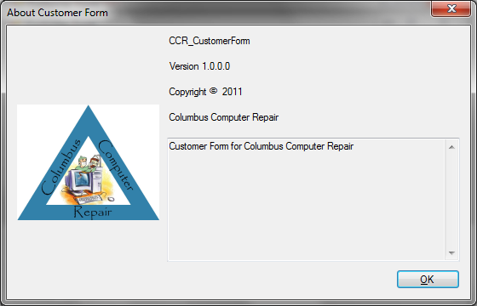

**Figure 12 – Customer Form About Box**

1. Click the red X or the **OK** button to close the program details box.

**Closing the Program**

1. To close the program, click **File** in the menu bar. Next, click **Exit**. Or, click the **Close** button.

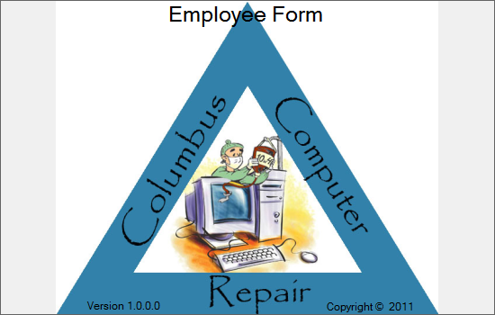

**Figure 13 – Columbus Computer Repair Employee Form Splash Screen**

**Introduction**

Columbus Computer Repair’s employee program allows users to add and delete employees from the database. The program will also allow users to update employee information as necessary. The following instructions will guide users through the steps necessary to maintain employee information in Columbus Computer Repair’s database.

**User Access**

User access is restricted to the following usernames: hrrep

**Viewing Employee Information**

1. Run CCR_EmployeeForm.exe

Columbus Computer Repair’s splash screen should display, with the name of the form on the top (see Figure 13).

1. Log in to the form using proper credentials via the login screen.

You should see the following form (see Figure 14).

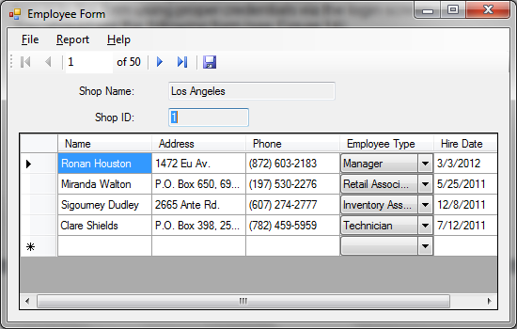

**Figure 14 – Employee Form Initial Screen**

1. To navigate through the store records to view employee information, click on the one of the navigation buttons. The **Move next** button displays the next store for which employee information is recorded. The **Move last** button displays the last store record in the database.The **Move previous** button displays the previous store record. The **Move first** button displays the first store record in the database. The **Current position** box displays the store id number.

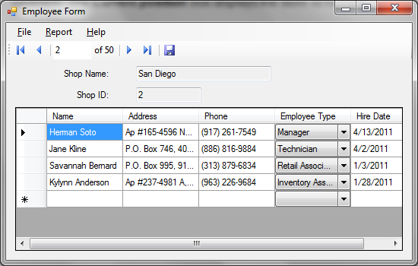

**Figure 15 – Employee Form Showing Employee Information**

**Adding an Employee**

1. Navigate to the store for which you wish to add employee information.
2. Click in the box next to the star in the new row.

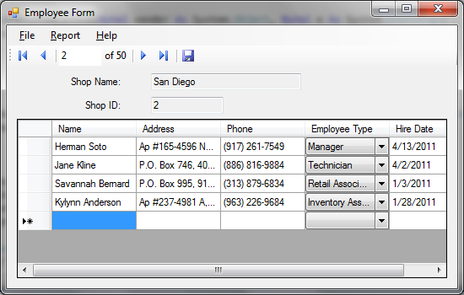

**Figure 16 – Employee Form Showing New Row**

1. Enter the new employee’s information into the appropriate boxes. Click on the arrow in the box by customer type to select what type of employee you are adding.

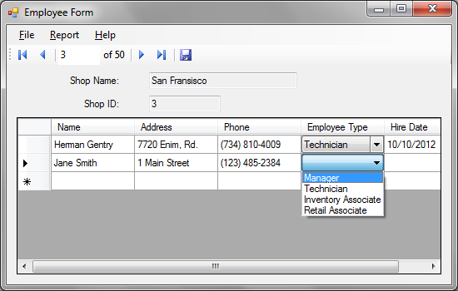

**Figure 17 – Employee Form Showing Employee Type Selection**

1. When finished adding employee information, click on the **Save** button on the navigation bar. The new employee should now show up in the list of employees for that store.

**Updating Employee Information**

1. Navigate to the store and click in the row where the employee’s information is located.
2. Change the information as necessary.
3. Click the **Save** button when finished.

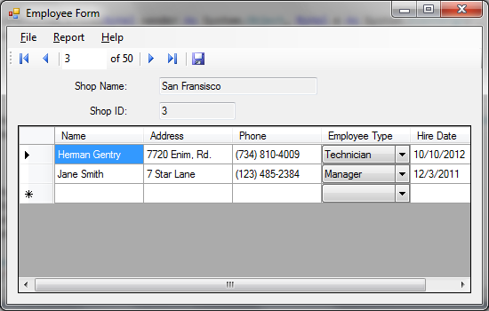

**Figure 18 – Employee Form Showing Updated Employee Information**

**Deleting an Employee**

1. Navigate to the store and click in the row where the employee information is located.
2. Press the Delete key on your keyboard.
3. Click the **Save** button when finished.

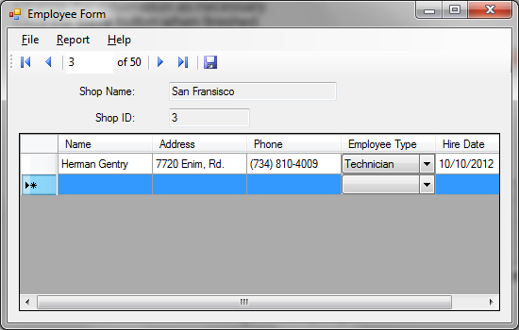

**Figure 19 – Employee Form Showing Empty Employee Row**

**Saving Database Changes**

1. Click the **Save** button. If you don’t save your changes as you go along, you will be prompted to do that when you attempt to exit the program.

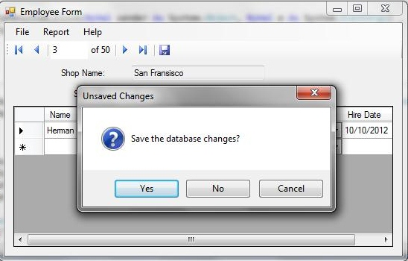

**Figure 20 – Employee Form Querying User to Save Database Changes**

1. To save changes to the database, click **Yes**. If you do not wish to save changes, click **No**. You will exit the program.
2. If you wish to continue editing the Employee database, click **Cancel**. The program will continue running.

**Displaying Employee Report**

1. To display the Employee Report, click Report in the menu bar. Next, click View. The Employee Report will display in a separate window.

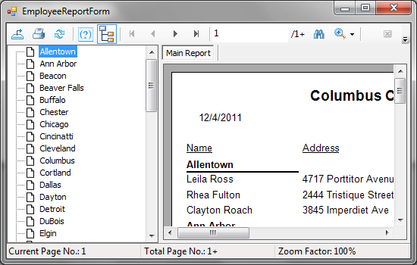

**Figure 21 – Employee Report Form**

**Displaying Program Information**

1. To display program information, click **Help** in the menu bar. Next click **About.**

The form’s about box should display information about the program.

1. Click the red X or the **OK** button to close the program details box.

**Closing the Program**

1. To close the program, click **File** in the menu bar. Next, click **Exit**. Or, click the **Close** button.

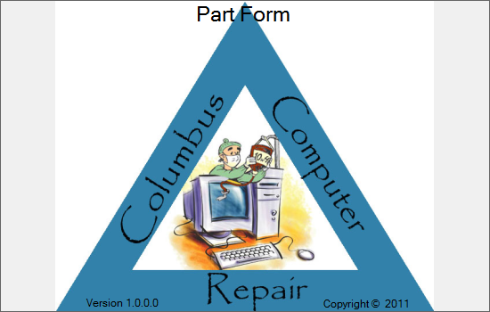

**Figure 22 – Columbus Computer Repair Part Form Splash Screen**

**Introduction**

Columbus Computer Repair’s parts inventory program allows users to add and delete customers from the database. The program will also allow users to update parts information as necessary. The following instructions will guide users through the steps necessary to maintain inventory information in Columbus Computer Repair’s database.

**User Access**

User access is restricted to the following usernames: manager and inventory.

**Viewing Parts Information**

1. Run CCR_PartForm.exe

Columbus Computer Repair’s splash screen should display, with the name of the form on the top (see Figure 22).

1. Log in to the form using proper credentials via the login screen.

You should see the following form (see Figure 23).

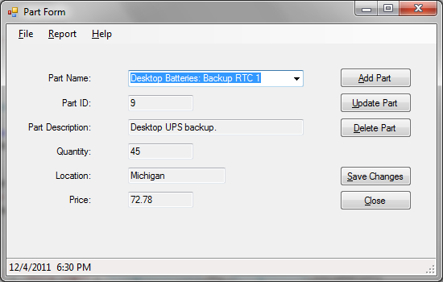

**Figure 23 – Part Form Initial Screen**

1. To display a different part, click on the arrow next to the part’s name. Navigate to the name of the part you are searching for.

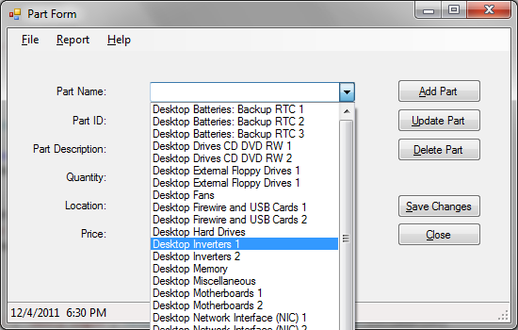

**Figure 24 – Part Form Navigation**

**Updating Part Information**

1. Navigate to the part that you wish to update.
2. Click the **Update Part** button.
3. Tab through the fields. Correct information by typing the new information in the box next the field you wish to update (see Figure 25). The status bar’s message will change to reflect that you are editing a part’s record.

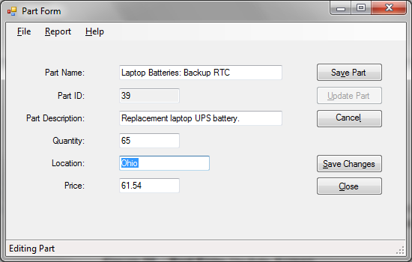

**Figure 25 – Part Form Update Screen**

1. When you have entered the information correctly and have no further information to update, click the **Save Part** button. The part’s information has been updated.

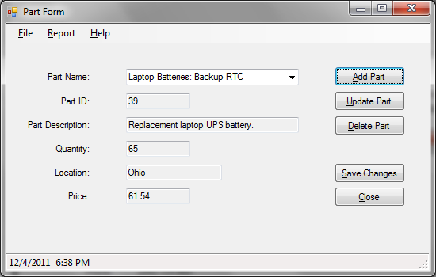**Figure 26 – Part Form Showing Updated Information**

1. If at any time you wish to stop editing a part’s information, click on the **Cancel** button. The Part Form screen will return to normal.

**Adding a Part**

1. Click the **Add Part** button.
2. Enter the new part’s information into the appropriate boxes. The status bar’s message will change to reflect that you are adding a part record.

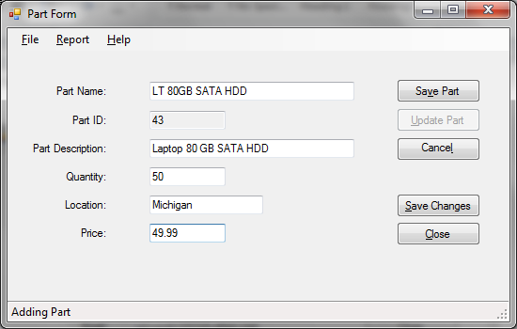

**Figure 27 – Customer Form Showing Part Add**

1. When you have entered the information correctly and have no further information to update, click the **Save Part** button. The part’s information has been updated.
2. If at any time you wish to stop adding a part, click on the **Cancel** button. The Part Form screen will return to normal.

**Deleting a Customer**

1. Navigate to the part you wish to delete.
2. Click the **Delete Part** button. A dialog box appears to confirm deletion of the record.

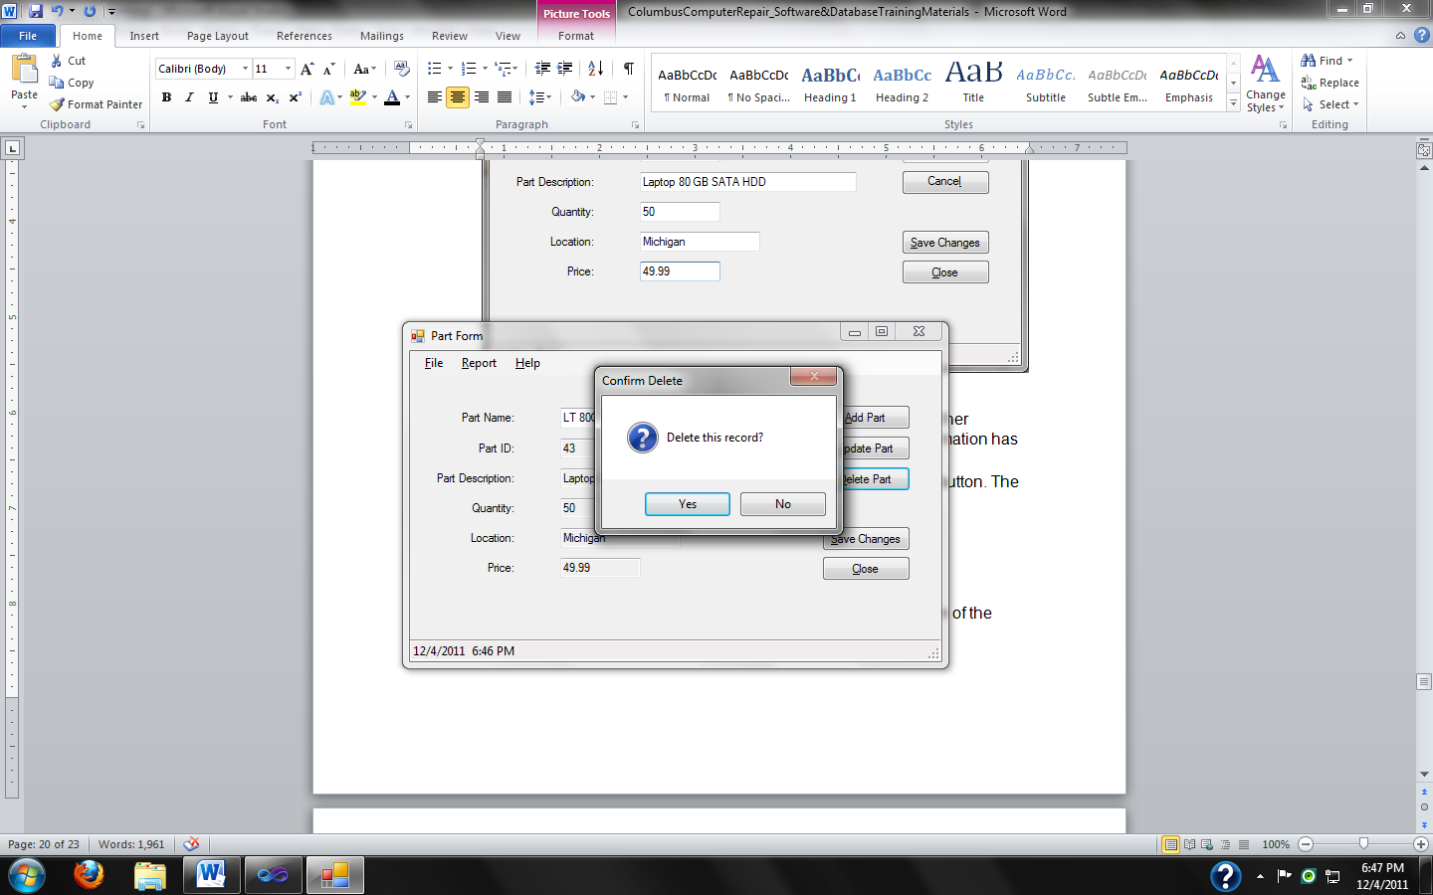

**Figure 28 – Part Form Showing Delete Dialog**

1. Click “Yes” to delete the record. If you do not wish to delete the record, click “No”. The Part Form should return to normal.

**\*\*Warning: Deleting parts should only be done with permission from your supervisor.**

**Saving Database Changes**

1. To save changes in the database, click the **Save Changes** button. Any changes you’ve made will be saved to the original database.

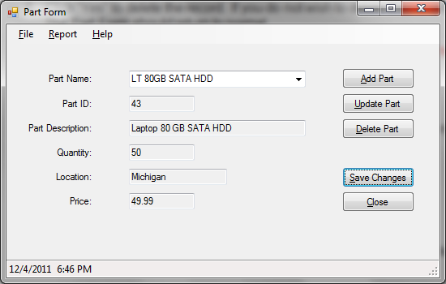

**Figure 29 – Part Form Saving Database Changes**

**Displaying Parts Inventory Report**

1. To display the Parts Inventory Report, click Report in the menu bar. Next, click View. The Parts Inventory Report will display in a separate window.

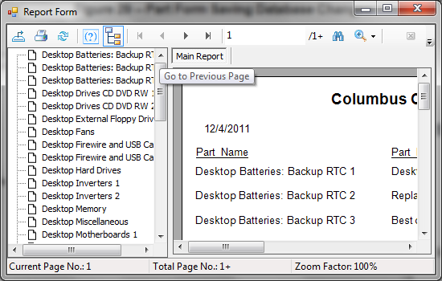

**Figure 30 – Part Report Form**

**Displaying Program Information**

1. To display program information, click **Help** in the menu bar. Next click **About.**

The form’s about box should display information about the program.

1. Click the red X or the **OK** button to close the program details box.

**Closing the Program**

1. To close the program, click **File** in the menu bar. Next, click **Exit**. Or, click the **Close** button.

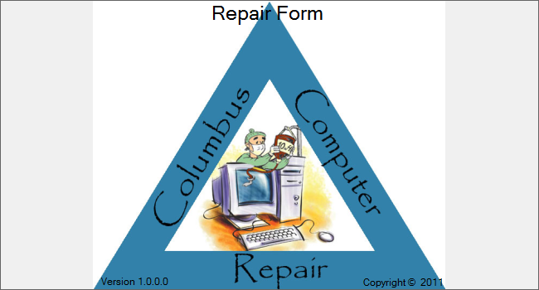

**Figure 31 – Columbus Computer Repair Repair Form Splash Screen**

**Introduction**

Columbus Computer Repair’s repair program allows users to add and delete repairs from the database. The following instructions will guide users through the steps necessary to maintain repair order information in Columbus Computer Repair’s database.

**User Access**

User access is restricted to the following usernames: manager, technician

**Viewing Repair Information**

1. Run CCR_RepairForm.exe

Columbus Computer Repair’s splash screen should display, with the name of the form on the top (see Figure 31).

1. Log in to the form using proper credentials via the login screen.

You should see the following form (see Figure 32).

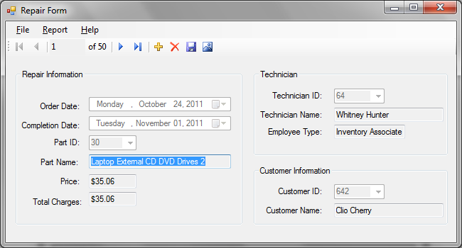

**Figure 32 – Repair Form Initial Screen**

To navigate through records to view repair information, click on the one of the navigation buttons. The **Move next** button displays the next repair record. The **Move last** button displays the last repair record in the database.The **Move previous** button displays the previous repair record. The **Move first** button displays the first repair record in the database. The **Current position** box displays the repair id number.

**Adding a Repair Order**

1. Click the **Add Record** button in the navigation bar.
2. Click on the arrows in the date-time pickers to select the appropriate order and completion dates.
3. Click on the arrows in the part name, technician name, and customer name to select the appropriate information for the order.

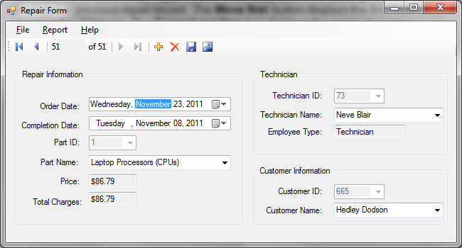

**Figure 33 – Repair Form Adding a Repair Order**

1. When you are finished entering the repair order information, click the **Save** button on the navigation bar. Click the **Cancel** button located next to the Save button to return to order navigation.

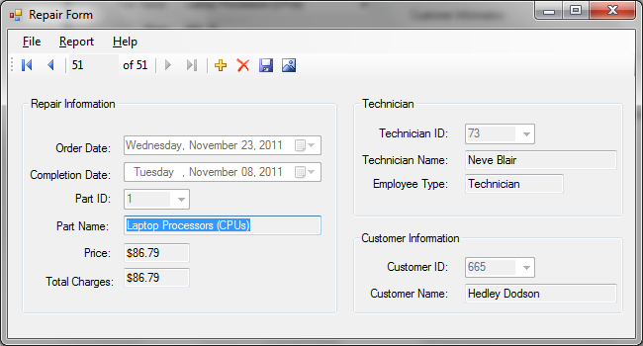

**Figure 34 – Repair Form Showing Added Repair Order**

**Deleting a Repair Order**

1. To delete a repair order, click on the **Delete** button in the navigation bar (not the title bar).
2. Click the Save button when finished.

**\*\*Warning: Deleting repair orders should only be done with permission from your supervisor.**

**\*\*Note: Updating repair orders can only be done through direct edits to the database by authorized users.**

**Saving Database Changes**

1. Click the **Save** button. If you don’t save your changes as you go along, you will be prompted to do that when you attempt to exit the program.

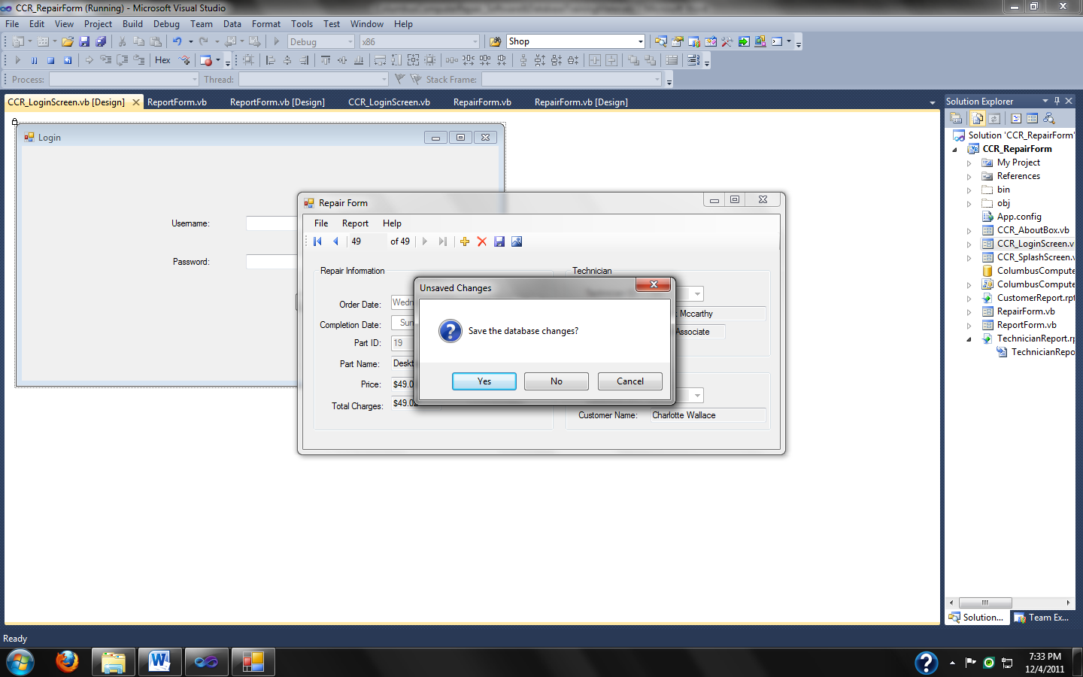

**Figure 35 – Repair Form Querying User to Save Database Changes**

1. To save changes to the database, click **Yes**. If you do not wish to save changes, click **No**. You will exit the program.
2. If you wish to continue editing the Repair database, click **Cancel**. The program will continue running.

**Displaying Reports**

1. To display a report, click Report in the menu bar. Next, click either Customer or Technician to view the report. The selected report will display in a separate window.

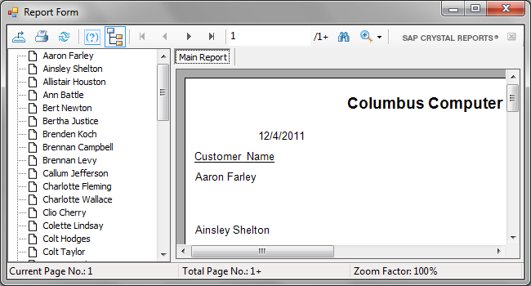

**Figure 36 – Customer Report Form**

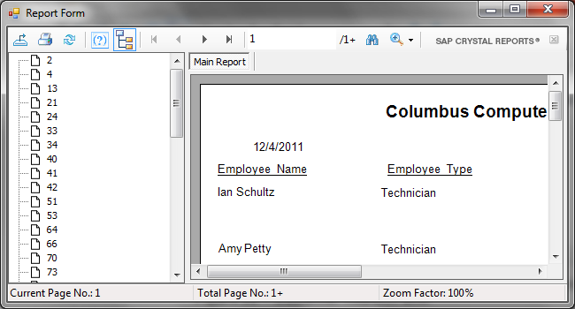

**Figure 37 – Technician Report Form**

**Displaying Program Information**

1. To display program information, click **Help** in the menu bar. Next click **About.**

The form’s about box should display information about the program.

1. Click the red X or the **OK** button to close the program details box.

**Closing the Program**

1. To close the program, click **File** in the menu bar. Next, click **Exit**. Or, click the **Close** button.

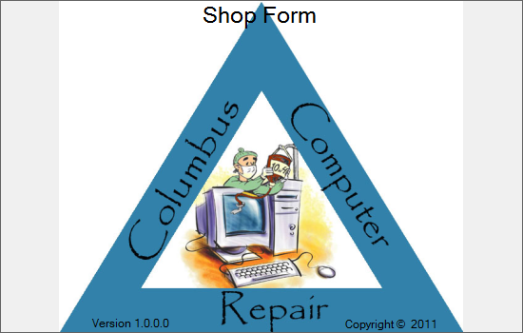

**Figure 38 – Columbus Computer Repair Shop Form Splash Screen**

**Introduction**

Columbus Computer Repair’s shop program allows updating of revenue and expense information as necessary. The following instructions will guide users through the steps necessary to maintain shop information in Columbus Computer Repair’s database.

**User Access**

User access is restricted to the following usernames: manager and analyst.

**Viewing Customer Information**

1. Run CCR_ShopForm.exe

Columbus Computer Repair’s splash screen should display, with the name of the form on the top (see Figure 38).

1. Log in to the form using proper credentials via the login screen.

You should see the following form (see Figure 39).

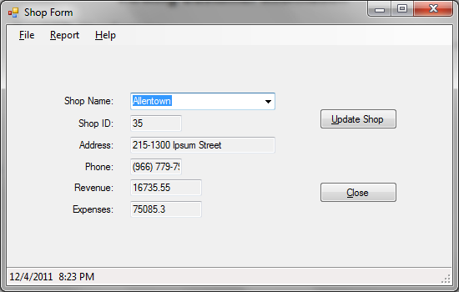

**Figure 39 – Shop Form Initial Screen**

1. To display a different shop’s information, click on the arrow next to the customer’s name. Navigate to the name of the shop you are searching for.

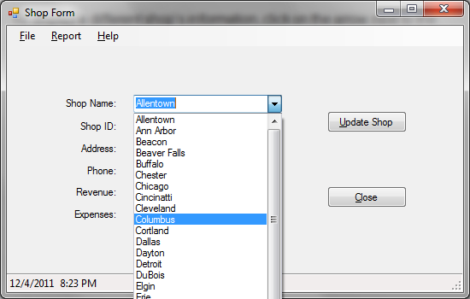

**Figure 40 – Shop Form Navigation**

To assist in navigation, begin typing the shop’s name into the box.

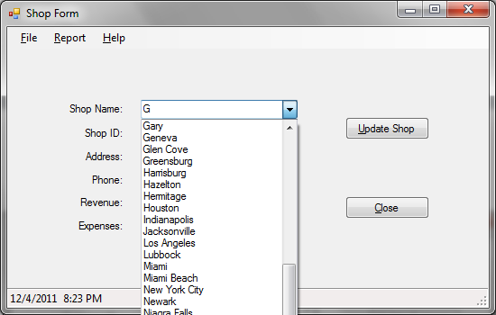

**Figure 41 – Shop Form Name Search**

**Updating Customer Information**

1. Navigate to the shop whose information you wish to update.
2. Click the **Update Shop** button.
3. Tab through the fields. Correct information by typing the new information in the box next the field you wish to update (see Figure 42). The status bar’s message will change to reflect that you are updating a shop record.

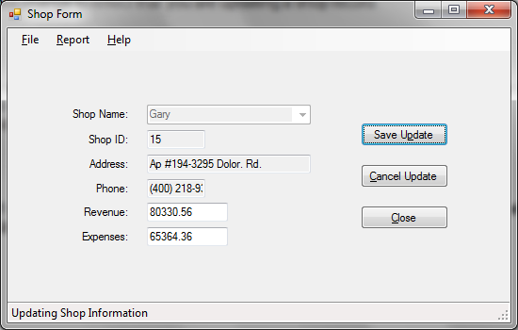

**Figure 42 – Shop Form Update Screen**

1. When you have entered the information correctly and have no further information to update, click the **Save Update** button. The shop’s information has been updated.

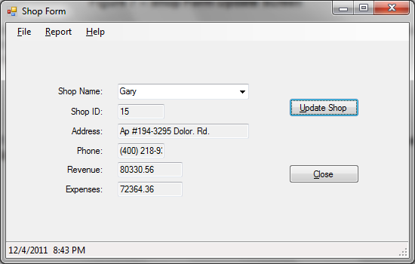

**Figure 43 – Customer Form Showing Updated Information**

1. If at any time you wish to stop editing a shop’s information, click on the **Cancel Update** button. The Shop Form screen will return to normal.

**Displaying Shop Report**

1. To display the Shop Report, click Report in the menu bar. Next, click View. The Employee Report will display in a separate window.

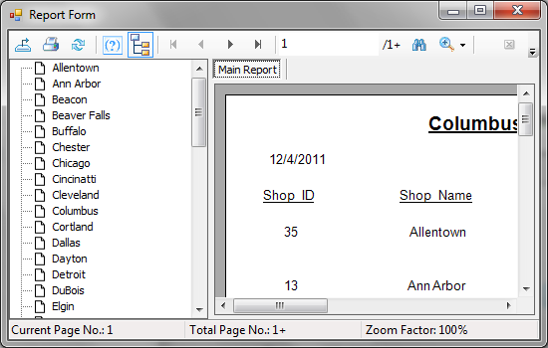

**Figure 44 – Shop Report Form**

**Displaying Program Information**

1. To display program information, click **Help** in the menu bar. Next click **About.**

The form’s about box should display information about the program.

1. Click the red X or the **OK** button to close the program details box.

**Closing the Program**

1. To close the program, click **File** in the menu bar. Next, click **Exit**. Or, click the **Close** button.

**\*\*Note: Adding or deleting a shop, or updating a shop’s information can only be done by direct edits to the database, for security purposes.**

**Adding a Record to the Columbus Computer Repair Database**

1. Double-click on the name of the table you want to add the record to.
2. Click in any of the fields in the new row (denoted by the star in the left hand column).

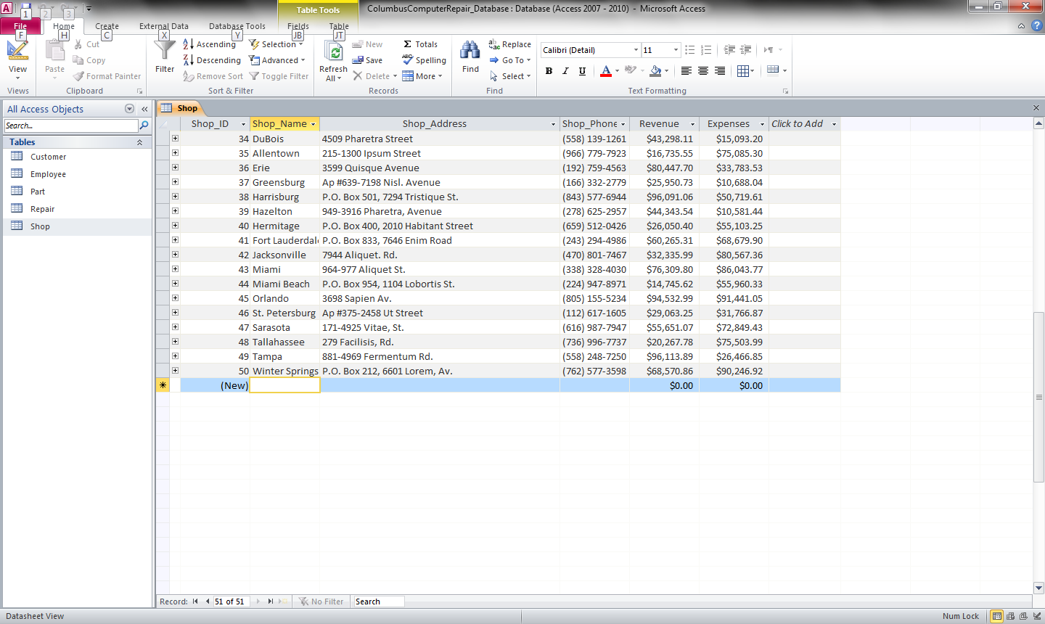

**Figure 45 – Adding a new row to the Columbus Computer Repair Database**

1. Enter the necessary information. Click the Save button in the title bar to save the new addition to the database.

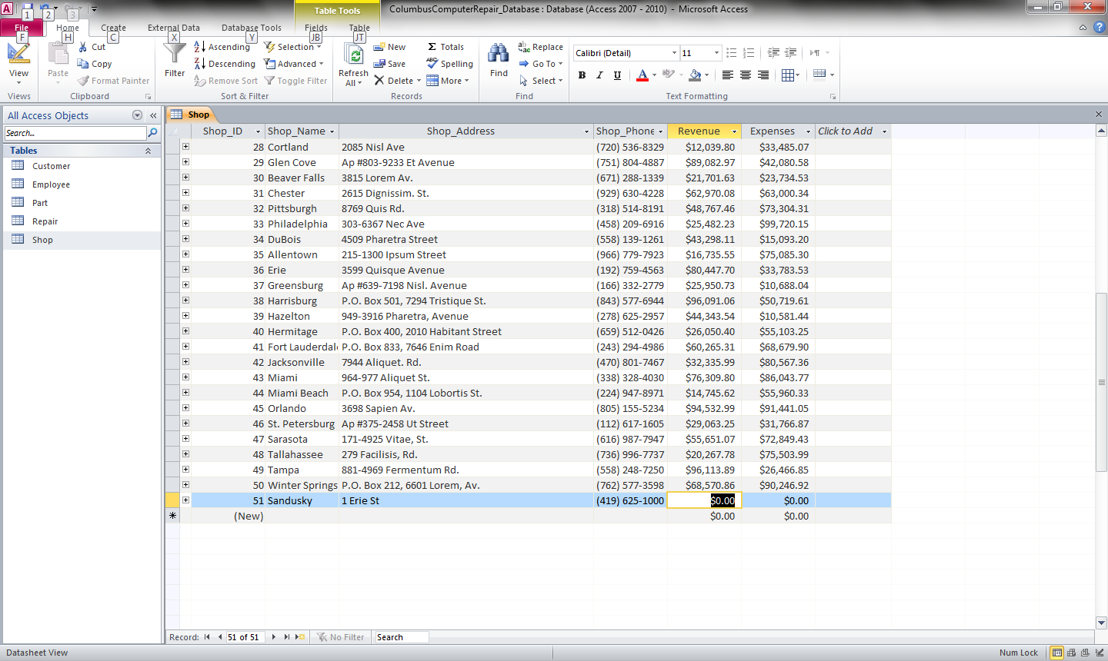

**Figure 46 – Database showing new row.**

**Updating a Record in the Columbus Computer Repair Database**

1. Double-click on the name of the table you want to add the record to.
2. Click in the field of the record you wish to alter.

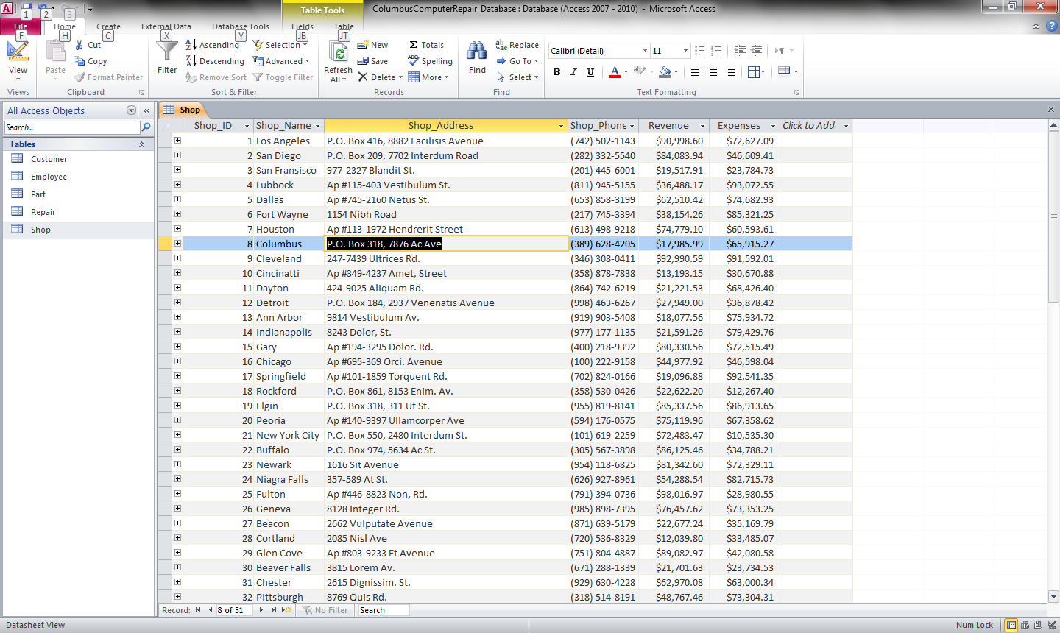

**Figure 47 – Updating a record in the Columbus Computer Repair database.**

1. Enter the new information. Click the **Save** button to save the changes to the record to the original database.

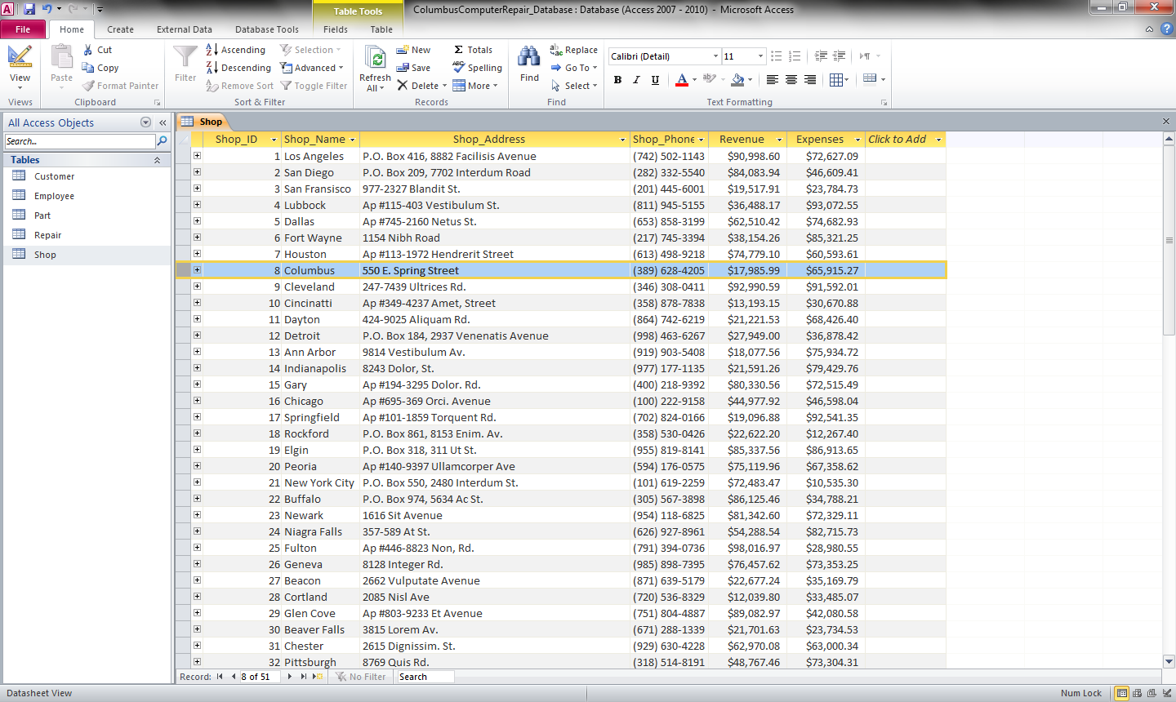

**Figure 48 – Database showing updated record.**

**Deleting a Record in the Columbus Computer Repair Database**

1. Double-click on the name of the table you wish to delete the record from.
2. Select the row with the record you wish to delete.

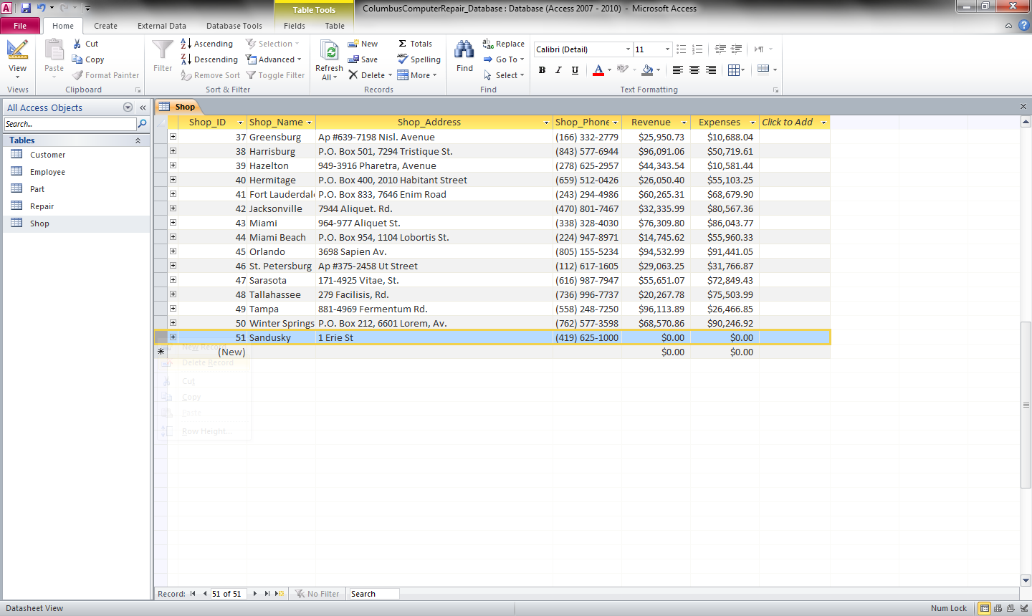

**Figure 49 – Deleting a record in the Columbus Computer Repair Database**

1. Press the delete key. Or, right-click on the record, and select Delete Record from the context menu. You will see the following dialog box.

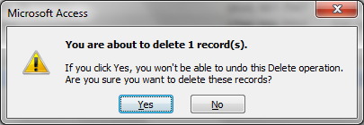

**Figure 50 – Delete dialog box**

1. To delete the record, click **Yes**. To keep the record, click **No**.

**Conclusion**

For questions, comments, and concerns about your Columbus Computer Repair software, please contact Abbott, Orcutt, & LaGrass IT Consultant Group at (614) 555-1212, or email us at aolitgroup@gmail.com.

For questions, comments and concerns about your Microsoft products, including Microsoft Access and Microsoft Office, please contact Microsoft.